

**WEB BASE SALON MANAGEMENT SYSTEM FOR**

**CLIPPER CUTS SALON**

**W.D.B SUDARSHANA**

**Registration Number: R227049 Index Number: 2270498**

**Name of Supervisor**

**B N P Mendis**

**2025 April**



# Declaration

This project is entirely my own original work. It has not been submitted previously for a degree at this university or any other institute.

To the best of my knowledge, the project does not contain any material published or written by another person, except for the sources that have been properly acknowledged and referenced within the text.

Student Name: Wanniarachchige Don Buddhika Sudarshana Registration Number: R227049

Index Number: 2270498

07.04.2025

Signature: Date:

This is to certify that this project is based on the work of Mr. W.D.B Sudarshana under my supervision. The project has been prepared according to the format stipulated and is acceptable standard.

Certified by

Supervisor Name: B N P Mendis



07.04.2025

Signature: Date:

# Abstract

Clipper Cuts Salon is a business that operates using a manual system, leading to inefficiencies in appointment scheduling, financial management, employee productivity tracking, and inventory management. The lack of a structured system makes it difficult to track historical data and make informed business decisions. Due to these limitations, customer satisfaction is affected, financial records are unorganized, and operational efficiency is compromised.

To address these issues, a web-based Salon Management System is being developed. The system includes modules for appointment scheduling, financial transaction tracking, employee productivity monitoring, and inventory management. Additionally, a reporting module is integrated to facilitate data-driven decision-making.

The system is being developed using an iterative incremental methodology, ensuring a structured and flexible approach to implementation. The project is built following **REST architecture**, making the system scalable and extensible. The backend is developed using Spring Boot, while the frontend is built using Angular. **UI components** are designed with Angular Material, and the database is managed by **MySQL Server**. System design and modeling are carried out using **MySQL Workbench** and **Visual Paradigm Tools**. The development environment includes **IntelliJ IDEA IDE**, with testing conducted using **Postman and Google Chrome browser**. Currently, several core modules are under development and testing. Once completed, the system will significantly enhance Clipper Cuts Salon’s operational efficiency, improve customer satisfaction, and provide accurate financial and business insights.

# Acknowledgement

This project would not have been possible without the invaluable support of several individuals.

First and foremost, I would like to express my heartfelt gratitude to Mrs. Kumudumali Gamage, owner of Clipper Cuts Saloon, and her staff enlightened me about the salon's processes and functionalities and cooperated well throughout the project development process.

My sincere gratitude goes to my supervisor, Mr. B N P Mendis. His guidance, encouragement, and expertise were instrumental in shaping this project from conception to completion. I am grateful for his counseling and supervising me throughout the development of the project.

I am also thankful to the BIT Coordinator of the University of Colombo School of Computing (UCSC) for providing me with the opportunity to undertake this project and apply the knowledge I gained during my studies.

My sincere thanks go out to my colleagues and their company and support were a great source of motivation throughout the project.

Finally, I would like to express my heartfelt appreciation to my family and parents. Their unwavering love, encouragement, and assistance throughout my life have been the foundation upon which I stand. Their support is given in every way possible throughout the process of this degree program of three years.

# Table of Content

Contents

Declaration 2

Abstract 3

Acknowledgement 4

Table of Content 5

List of Figures, List of Tables 6

Chapter 1 7

1.1 Introduction 7

1.2 Motivation 7

1.3 Objective 8

1.4 Scope 8

Chapter 2 – Analysis 9

2.1 Review of similar system 9

2.1.1 Rosy Salon Software 9

2.2 Existing System 11

Identified Issues 12

2.3 Proposed Solution 12

2.4 Benefits of the Proposed System 12

2.5 System Requirements 13

Chapter 3 - Design 14

3.1 Design of Solutions 14

Selected Solution and Justification 14

3.2 Architectural design 14

3.2.1 Class Diagrams 16

3.4 Activity Diagram 17

3.5 Sequence Diagram 18

3.7 User Interface Designs 22

3.8 Proposed System Architecture 24

# List of Figures, List of Tables

|  |  |
| --- | --- |
| Figure 2.1 : example for similar systems | 3 |
| Figure 2.2: Use case diagram of the Existing System | 5 |
| Figure 3.1: Use case diagram of the Receptionist | 8 |
| Figure 3.2: Use case diagram of the Beautician | 9 |
| Figure 3.3: Use case diagram of the Cashier | 9 |
| Figure 3.4: Use case diagram of the Customer | 10 |
| Figure 3.5: Shows the basic class diagram of the system | 10 |
| Figure 3.6: Shows the activity diagram of add an Appointment scenario. | 11 |
| Figure 3.7: ER diagram of the customer module | 12 |
| Figure 3.8: ER diagram of the Employee module | 12 |
| Figure 3.9: ER diagram of the Appointment module | 13 |
| Figure 3.10: ER diagram of the Service module | 13 |
| Figure 3.11: ER diagram of the Invoice module | 14 |
| Figure 3.12: ER diagram of the Invoice module | 14 |
| Figure 3.13: mockup design of the Login page | 15 |
| Figure 3.14: mockup design of the Report page | 15 |
| Figure 3.15: mockup design of the Appointment page | 16 |
| Figure 3.16: High Level System Architecture in Proposed System | 17 |

# Chapter 1

# Introduction

Clipper Cuts Salon still use manual and paper-based approaches to operate their business. The following drawbacks have been recognized in this organization.

* + - Inefficient appointment scheduling leading to customer dissatisfaction.
    - Lack of accurate financial data hindering income/expense measurement and informed decision-making.
    - Difficulty tracking employee performance.
    - Manual inventory management leading to potential stockouts and inefficiencies.
    - Inaccessible historical data hampering business analysis and growth strategies.

This project proposes the implementation of a web-based salon management system to address the aforementioned drawbacks. The system will streamline appointment scheduling, automate financial tracking, facilitate employee performance monitoring, enhance inventory control, and provide readily accessible historical data. This will empower Clipper Cuts Salon to improve customer satisfaction, optimize operations, and make data-driven business decisions.

# Motivation

The current business practices within the Clipper Cuts highlight the serious need for an efficient salon management system. As observed, the industry standard remains heavily dependent on manual and paper-based processes. This outdated approach presents significant challenges for the organization, hindering its ability to compete effectively in a dynamic and competitive market.

Identified Issues with Manual Processes

* + - Inefficient Appointment Management: Lack of a proper system leads to scheduling conflicts, frustrating both customers and staff. This negatively impacts customer satisfaction and loyalty.
    - Limited Financial Oversight: The absence of a dedicated financial management system makes it impossible to accurately track daily and monthly income and expenses. Without this vital data, informed financial decision-making becomes a significant challenge.
    - Employee Performance Opacity: Evaluating employee performance is cumbersome and unreliable without a system to track efficiency. This hinders the identification of top performers and limits opportunities for targeted improvement.
    - Inventory Management Challenges: Manual inventory management is prone to errors and inefficiencies. Stock outs and overstocking become frequent occurrences, negatively impacting revenue and customer experience.
    - Data Accessibility Issues: Historical financial and operational data is difficult or impossible to access with manual systems.
    - Decision-Making Difficulties: Without access to accurate and readily available data, making informed business decisions becomes a daunting task.

# Objective

A strong, web-based salon management system is highly recommended to address these core issues and steer the company toward peak performance. In the end, this all-inclusive solution will promote strategic growth by streamlining daily processes, providing vital operational analytics, and enabling data-driven decision-making.

* + - Enhance customer satisfaction through efficient appointment scheduling and personalized service.
    - Gain real-time financial transparency and make informed financial decisions.
    - Improve employee performance through effective tracking and targeted training.
    - Optimize inventory management and minimize waste.
    - Access and analyze historical data to gain valuable business insights.

# Scope

The main scope of this project is the development of a web-based salon management system. This system is designed to streamline and automate various salon operations,

1. Appointment Management
2. Customer Management
3. Service Management
4. Inventory Management
5. Supplier Management
6. Billing and Payment Processing
7. Package management
8. Dress rental
9. Report Generation
10. Employee Management
11. User Management
12. Promotion and Discount Management
13. Product Management
14. Customer Feedback Management
15. Good Received Notes
16. Purchase Order

# Chapter 2 – Analysis

During the analysis phase of the Software Development Life Cycle, discussions are held with the client to understand their software development needs. The goal of this phase is to gather all the project details. In other words, the requirement analysis phase focuses on capturing every aspect of each requirement and ensuring that all stakeholders have a clear understanding of the project's scope and how each requirement will be addressed.

# Review of similar system

Similar systems are analyzed to identify the requirements for the proposed solution. This helps us gain a clear understanding of the features and functionalities our system should include.

# Rosy Salon Software

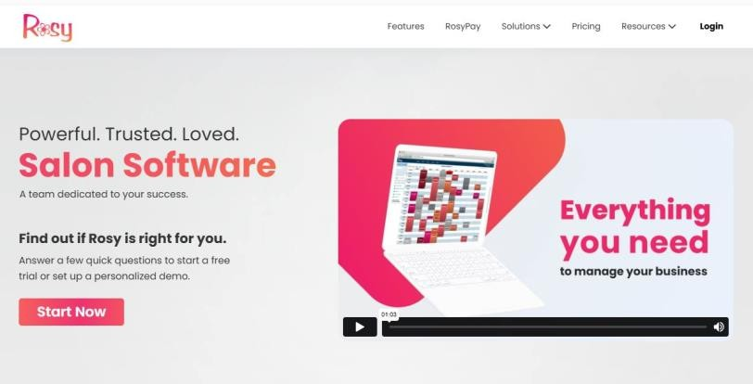

*Figure 2. 1: example for similar systems*

Rosy Salon Software is an all-in-one, easy-to-use solution for salon management that aims to make your operations smoother, boost customer satisfaction, and increase overall productivity. It offers a variety of features to help with everyday tasks, such as

**Functional features**

Functional features of Rosy Salon Software as below,

* + - 1. Appointment Scheduling:
      2. Client Management
      3. Service Management
      4. Inventory Management
      5. Payment Processing
      6. Staff Management.

**Non-Functional features**

Non-Functional features of Rosy Salon Software as below,

1. User Friendly Interface
2. Support and Maintenance
3. Scalability

# Existing System

Clipper Cuts Salon currently operates using a manual, paper-based system.

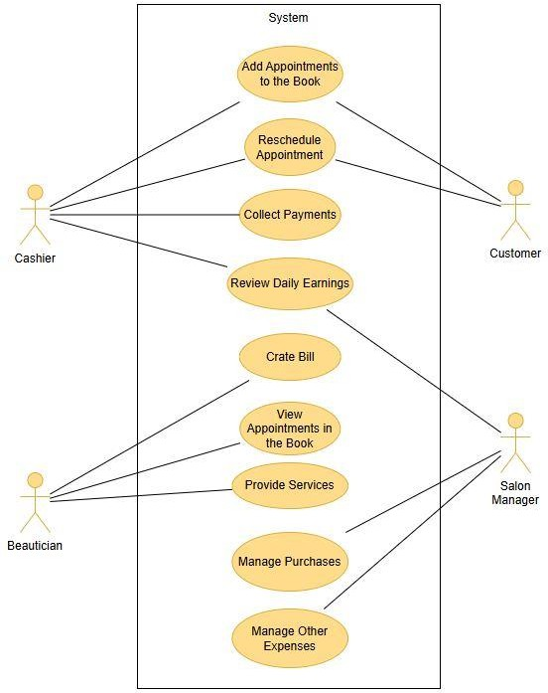

*Figure 2. 2: Use case diagram of the Existing System*

# Identified Issues

This leads to several problems:

* Inefficient appointment scheduling - Manual scheduling can be inconvenient and error-prone, leading to wait times, double bookings, and customer dissatisfaction.
* Inaccurate financial data - Paperwork makes it difficult to track income, expenses, and profitability accurately, hindering informed decision-making.
* Employee performance issues - Manual tracking of employee performance is ineffective and lacks transparency.
* Inventory management problems - Manual inventory control is prone to stockouts and inefficiencies.
* Limited data accessibility - Historical data is inaccessible, making it difficult to analyze business trends and develop growth strategies.

# Proposed Solution

A web-based salon management system is proposed to address these issues. This system will offer several functionalities:

* Automated financial tracking: The system will automatically track income, expenses, and inventory, providing real-time financial insights.
* Employee performance monitoring: The system will facilitate tracking of employee performance metrics, allowing for targeted training and improvement.
* Inventory control: The system will manage inventory levels, reducing stockouts and optimizing stock management.
* Historical data analysis: The system will store and provide access to historical data for business analysis and strategic planning.

# Benefits of the Proposed System

Implementing this system offers several benefits for Clipper Cuts Salon:

* Enhanced customer satisfaction: Improved appointment scheduling and potentially personalized service features will lead to happier clients.
* Financial transparency: Real-time financial data allows for better decision-making regarding pricing, marketing, and resource allocation.
* Improved employee performance: Tracking and feedback mechanisms can motivate employees and enhance their effectiveness.
* Optimized inventory management: Reduced stockouts and improved stock control will lead to cost savings and operational efficiency.
* Data-driven decision making: Access to historical data allows for informed business decisions and growth strategies.

# System Requirements

Functional Requirements:

* Customer management including profiles, booking history, and preferences.
* Service management with detailed descriptions, pricing, and duration.
* Employee management with roles, schedules, and performance tracking.
* Inventory management with stock levels, purchase tracking, and low-stock alerts.
* Point-of-sale functionality for service payments and product sales.
* Reporting capabilities for income, expenses, inventory, employees and appointments.

Non-Functional Requirements:

* User-friendly interface for staff.
* Secure user authentication and data encryption.
* Scalability to accommodate future growth.
* System availability and reliability.

# Chapter 3 - Design

# Design of Solutions

Design of Web-based Salon Management System for Clipper Cuts. We will follow a systematic approach to design the salon management system, utilizing various design tools to achieve an efficient and user-friendly solution.

1. Stand-alone desktop application
2. Web based salon management system.

# Selected Solution and Justification

A web-based salon management system is the preferred solution due to its,

* + Accessibility - Accessible from any device with an internet connection, allowing staff to manage operations remotely and clients to book appointments conveniently.
  + Scalability - Easily scalable to accommodate future growth in clients, services, and staff.
  + Cost-Effectiveness - Potentially lower development and maintenance costs compared to a custom desktop application.

# Architectural design

* + 1. **Use Case Diagrams**

Use case modelling will capture the interactions between users and the system for functions like booking appointments, managing inventory, and employee management etc.

Following figure 3.1: Shows the Use case diagram of the Receptionist.

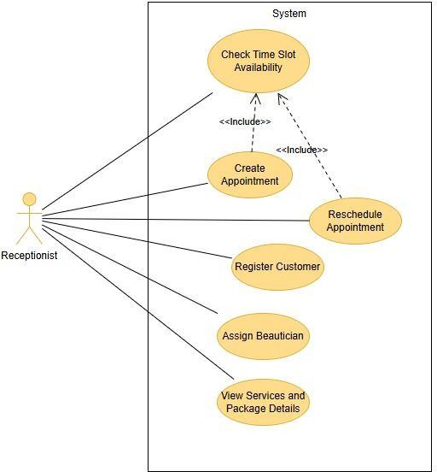

*Figure 3. 1: Use case diagram of the Receptionist*

Following figure 3.2: Shows the Use case diagram of the Beautician.

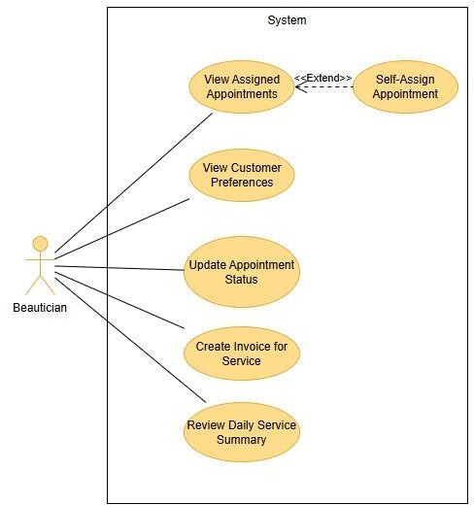

*Figure 3.2: Use case diagram of the Beautician*

Following figure 3.3: Shows the Use case diagram of the Cashier.

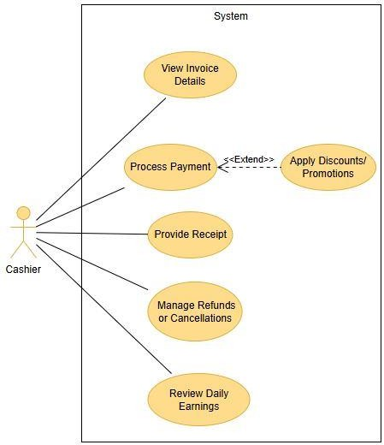

*Figure 3.3: Use case diagram of the Cashier*

Following figure 3.4: Shows the Use case diagram of the Customer.

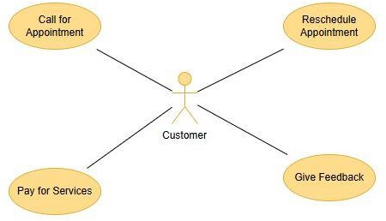

*Figure 3.4: Use case diagram of the Customer*

# Class Diagrams

Class Diagrams will define the system classes (e.g., User, Appointment, Service) with their attributes and methods, providing a blueprint for system development.

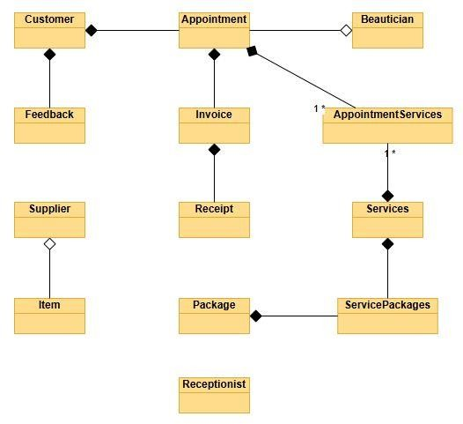

*Figure 3.5: Shows the basic class diagram of the system*

# Activity Diagram

The activity diagram is another important behavioral diagram in the UML diagram to describe dynamic aspects of the system. An activity diagram is essentially an advanced version of a flow chart that models the flow from one activity to another activity.

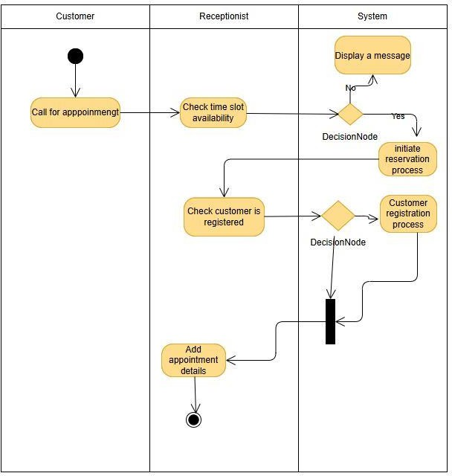

*Figure 3.6: Shows the activity diagram of add an Appointment scenario.*

# Sequence Diagram

Sequence diagrams primarily illustrate the order of interactions between objects. While often seen as tools for developers, they are also valuable for business staff to visualize and communicate how business processes and objects interact.

At the requirements phase, sequence diagrams help refine use cases into detailed interaction flows, serving as a formal requirements document for future system implementations. During the design phase, technical staff use them to define and validate object interactions and guide system behavior and architecture.

# 

*Figure 3. 7: Sequence Diagram of the customer module*

# Data modeling

Entity-Relationship Diagrams (ERD) will depict the data entities (clients, services, employees, appointments, inventory) and their relationships, ensuring data integrity.

Following figure 3.6: Shows the ER diagram of the Customer module.

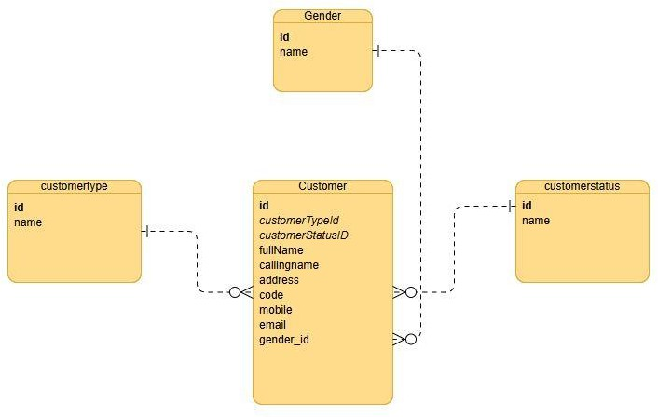

*Figure 3. 7: ER diagram of the customer module*

Following figure 3.8: Shows the ER diagram of the Employee module.

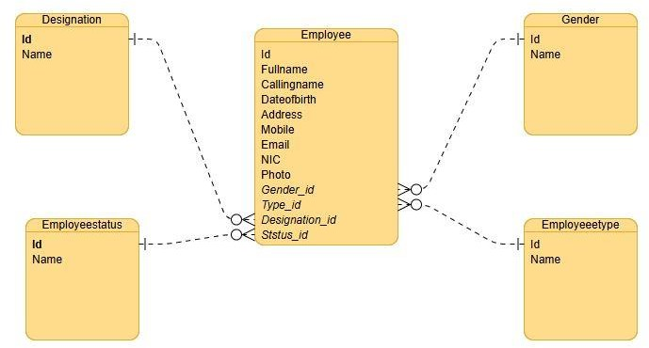

*Figure 3. 8: ER diagram of the Employee module*

Following figure 3.9: Shows the ER diagram of the Appointment module.

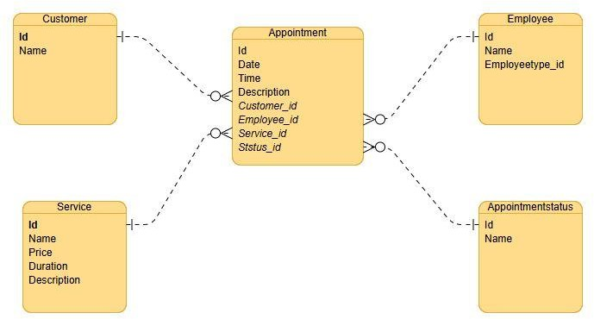

*Figure 3. 9: ER diagram of the Appointment module*

Following figure 3.10: Shows the ER diagram of the Service module.

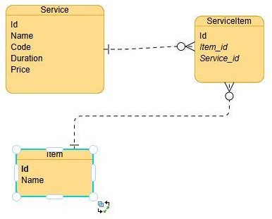

*Figure 3. 10: ER diagram of the Service module*

Following figure 3.11: Shows the ER diagram of the Invoice module.

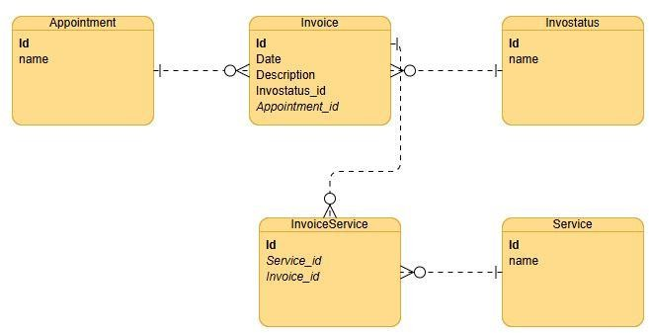

*Figure 3. 11: ER diagram of the Invoice module*

Following figure 3.12: Shows the ER diagram of the Invoice module.

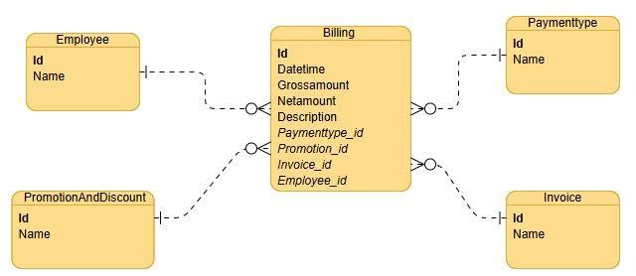

*Figure 3. 12: ER diagram of the Invoice module*

# User Interface Designs

The user interfaces were designed with a focus on user requirements. This meant arranging easy-to-access, understandable, and usable elements to facilitate user actions. The design consists of principles of interaction design, visual design, and information architecture.

Following figure 3.13: Shows the mockup design of the Login page of the system.

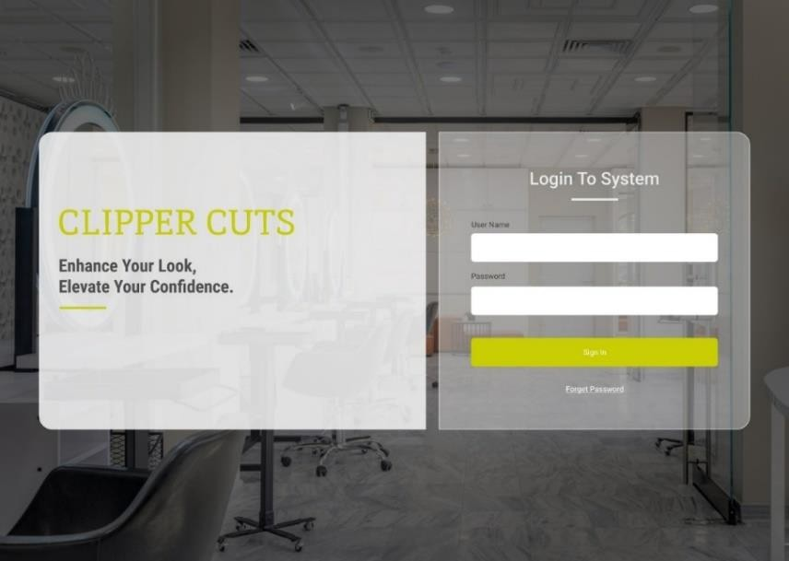

*Figure 3.13: mockup design of the Login page*

Following figure 3.14: Shows the mockup design of the Reports page of the system.

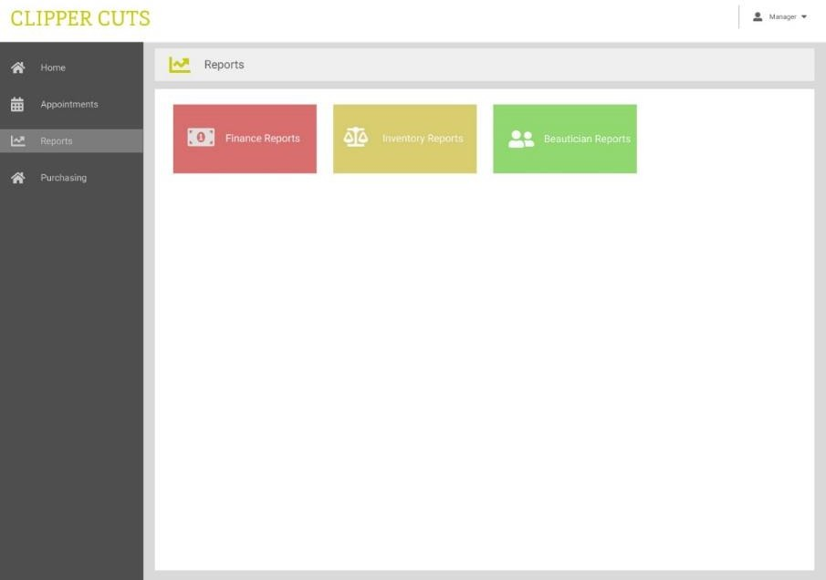

*Figure 3.14: mockup design of the Report page*

Following figure 3.15: Shows the mockup design of the Appointment page of the system.

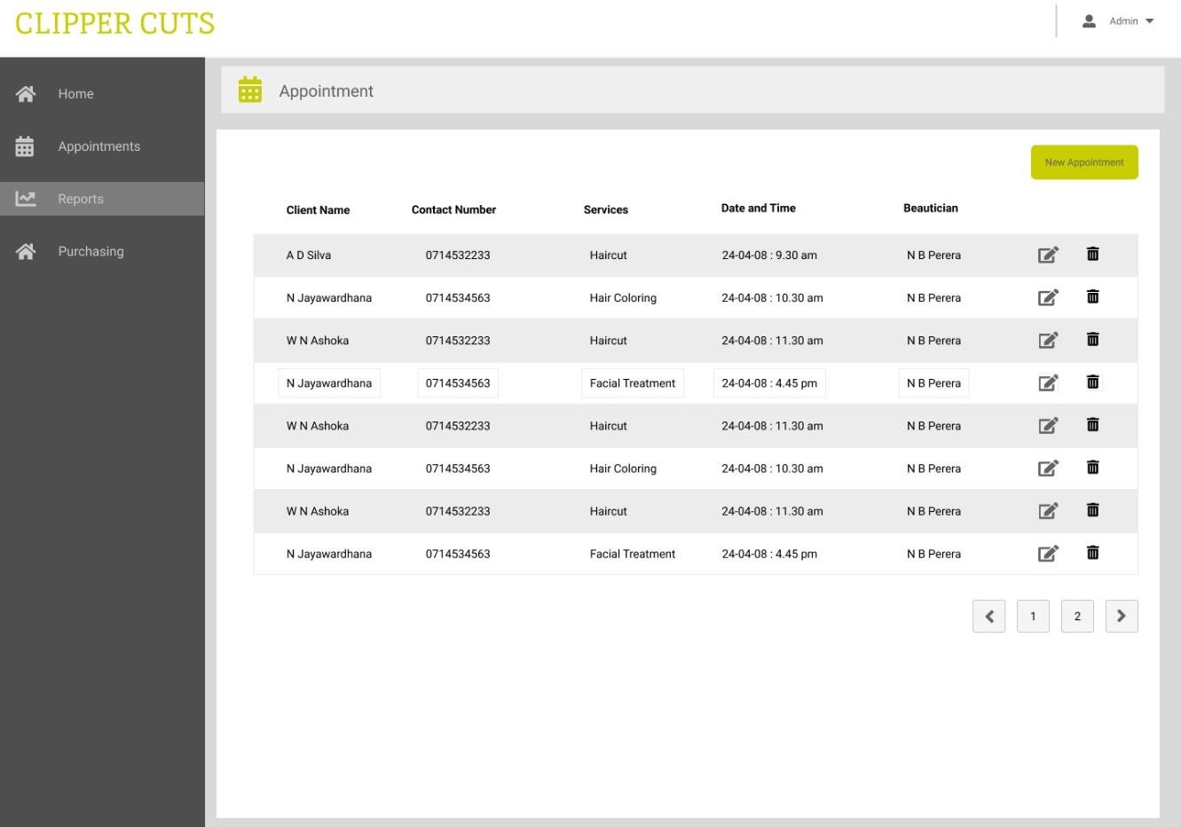

*Figure 3.15: mockup design of the Appointment page*

All appointments can be managed from this page. The salon manager or cashier can create appointments, reschedule appointments, and cancel appointments.

# Proposed System Architecture

**Java Spring Boot**

Java Spring Boot is a powerful tool that simplifies the development of web applications and microservices using the Java Spring Framework. It simplifies setup and configuration, enabling developers to build and deploy applications more quickly and efficiently with minimal code.

The proposed system web API (Back end) is Java Spring Boot.

**Angular**

Angular is a platform and framework for building single-page client applications using HTML and TypeScript.

Angular is used for front-end programming in the proposed system.

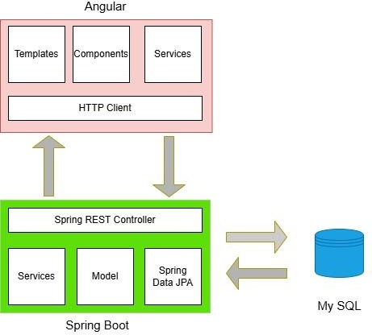

*Figure 3.16: High Level System Architecture in Proposed System*